**Measures of Central Tendency**

Measure of central tendency is a summary that describe and represents the center point of a data set which specify the location where most of the values fall in a distribution.”

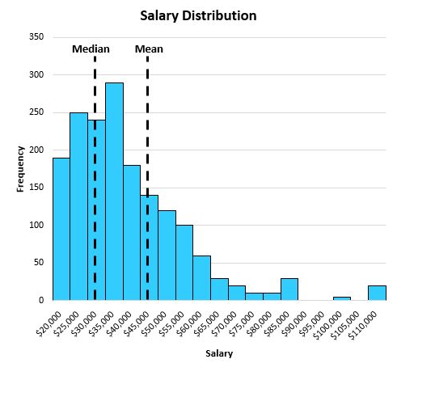

As from the above graph, you can take the idea of a range where most of the value are occurring. Measure of central tendency is all about this concept, that gives us an idea to represent data with values and its frequency.

Measure of central tendency can be can be defined in three ways:

• Mean

• Median

• Mode

Now, let’s discuss all the three aspects and understand their coverage in measure of central tendency.

Mean: -

Mean is the average of a given data. It is calculated as sum of all values divided by total number of values.

For the dataset, [10,29,15,10,30,45,47,42,48,55,59,50,89,90,87,82,91,70,77,76,60,20,50,98,76,65,70,50,79,93]

Mean=58

Mean takes all the values and if any of the value changes in the data, then mean also get changed. It also takes outliers in its calculation and thus in some cases, it does not provide accurate measure of tendency. So, it is better to use mean when the distribution is symmetrical.

Median: -

Median gives the middle value of the dataset. It divides the distribution into two halves after arranging the data in an ascending order.

o Median for even values can be calculated as, sum of values present at (n/2) and (n/2+1) positions divided by 2, where n is the no. of observations.

o Median for odd value can be calculated as, value present at (n+1)/2 position divided by 2, where n is the no. of observations.

For the same dataset, [10,29,15,10,30,45,47,42,48,55,59,50,89,90,87,82,91,70,77,76,60,20,50,98,76,65,70,50,79,93]

Median= 59.5

Median gives us exact middle value for a distribution. It does not involve all the values in its calculation and outliers effect the value of a median in a minimal way. So, it is better to use the median when the distribution is skewed.

Mode: -

Mode is the observation that is occurring most frequently in a data set. It is the value that is occurring most of the times in a distribution.

**When to use the mode**

It is best to use the mode when you are working with categorical data and you want

to know which category occurs most frequently.

**Example**

* If you want to find the most frequently used mobile phone between mi, apple oppo
* If you want to choice three website design and you want to know which design and you want know which design people prefer most

For the same above dataset,

[10,29,15,10,30,45,47,42,48,55,59,50,89,90,87,82,91,70,77,76,60,20,50,98,76,65,70,50,79,93]